**TERM PROJECT**

**PHASE 2 SUBMISSION**

**DATABASE-LAB**



**GROUP MEMBERS**

|  |  |
| --- | --- |
| **NAME** | **REGISTRATION#** |
| **USMAN MAHMOOD** | **L1S19BSSE8001** |
| **SYED ASJAD SOHAIL** | **L1S19BSSE8003** |
| **GOHAR INAM** | **L1S19BSSE0022** |

**Faculty of Information Technology**

**University of Central Punjab**

**Schema Image by Reverse Engineer:**

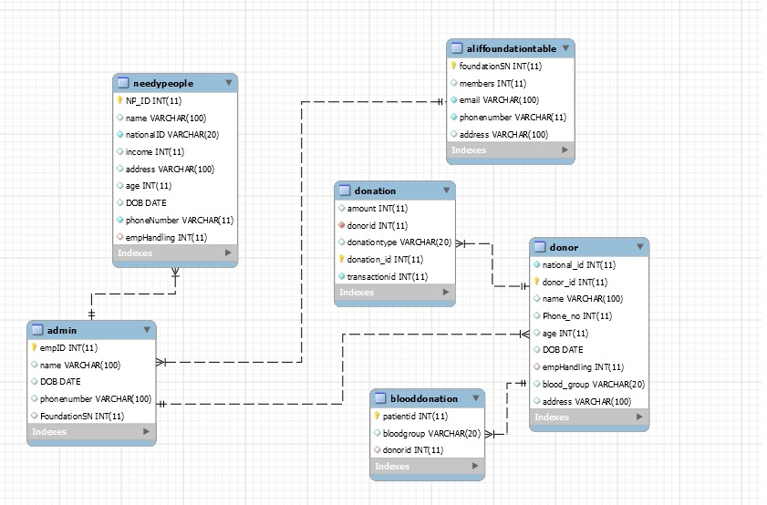

**Final Relational Scheme Image:**

